Participant instructions for sampling

Version: 4.0, 8 November 2023
Local Lead Investigator: [local_lead_investigator_name]
Chief Investigator: Dr JK Baillie, University of Edinburgh

The GenOMICC Study – Sampling information

Thank you for agreeing to participate in the GenOMICC study, we very much appreciate your support. We now enclose your DNA sample kit. Your DNA sample may be obtained from blood or saliva, and this will have been discussed with you during the consent process.

Blood sample

Please pass the kit to the nurse who comes to take your sample and they will package your blood sample for you. These tubes are not suitable for saliva collection.

Saliva Sample

The saliva kit includes instructions to guide you through the sampling process. It’s really important that you provide enough saliva, so do try to fill to the line on the tube and then close tightly. Once complete, please package this up (see images below) and post in your nearest post box. Postage is already paid, and we use packaging that has been approved for this purpose.

Packaging the samples
Place the sample into the plastic bag with the absorbent pad and seal closed.
Slot the bag inside the specimen box and secure tightly with the security seal label.
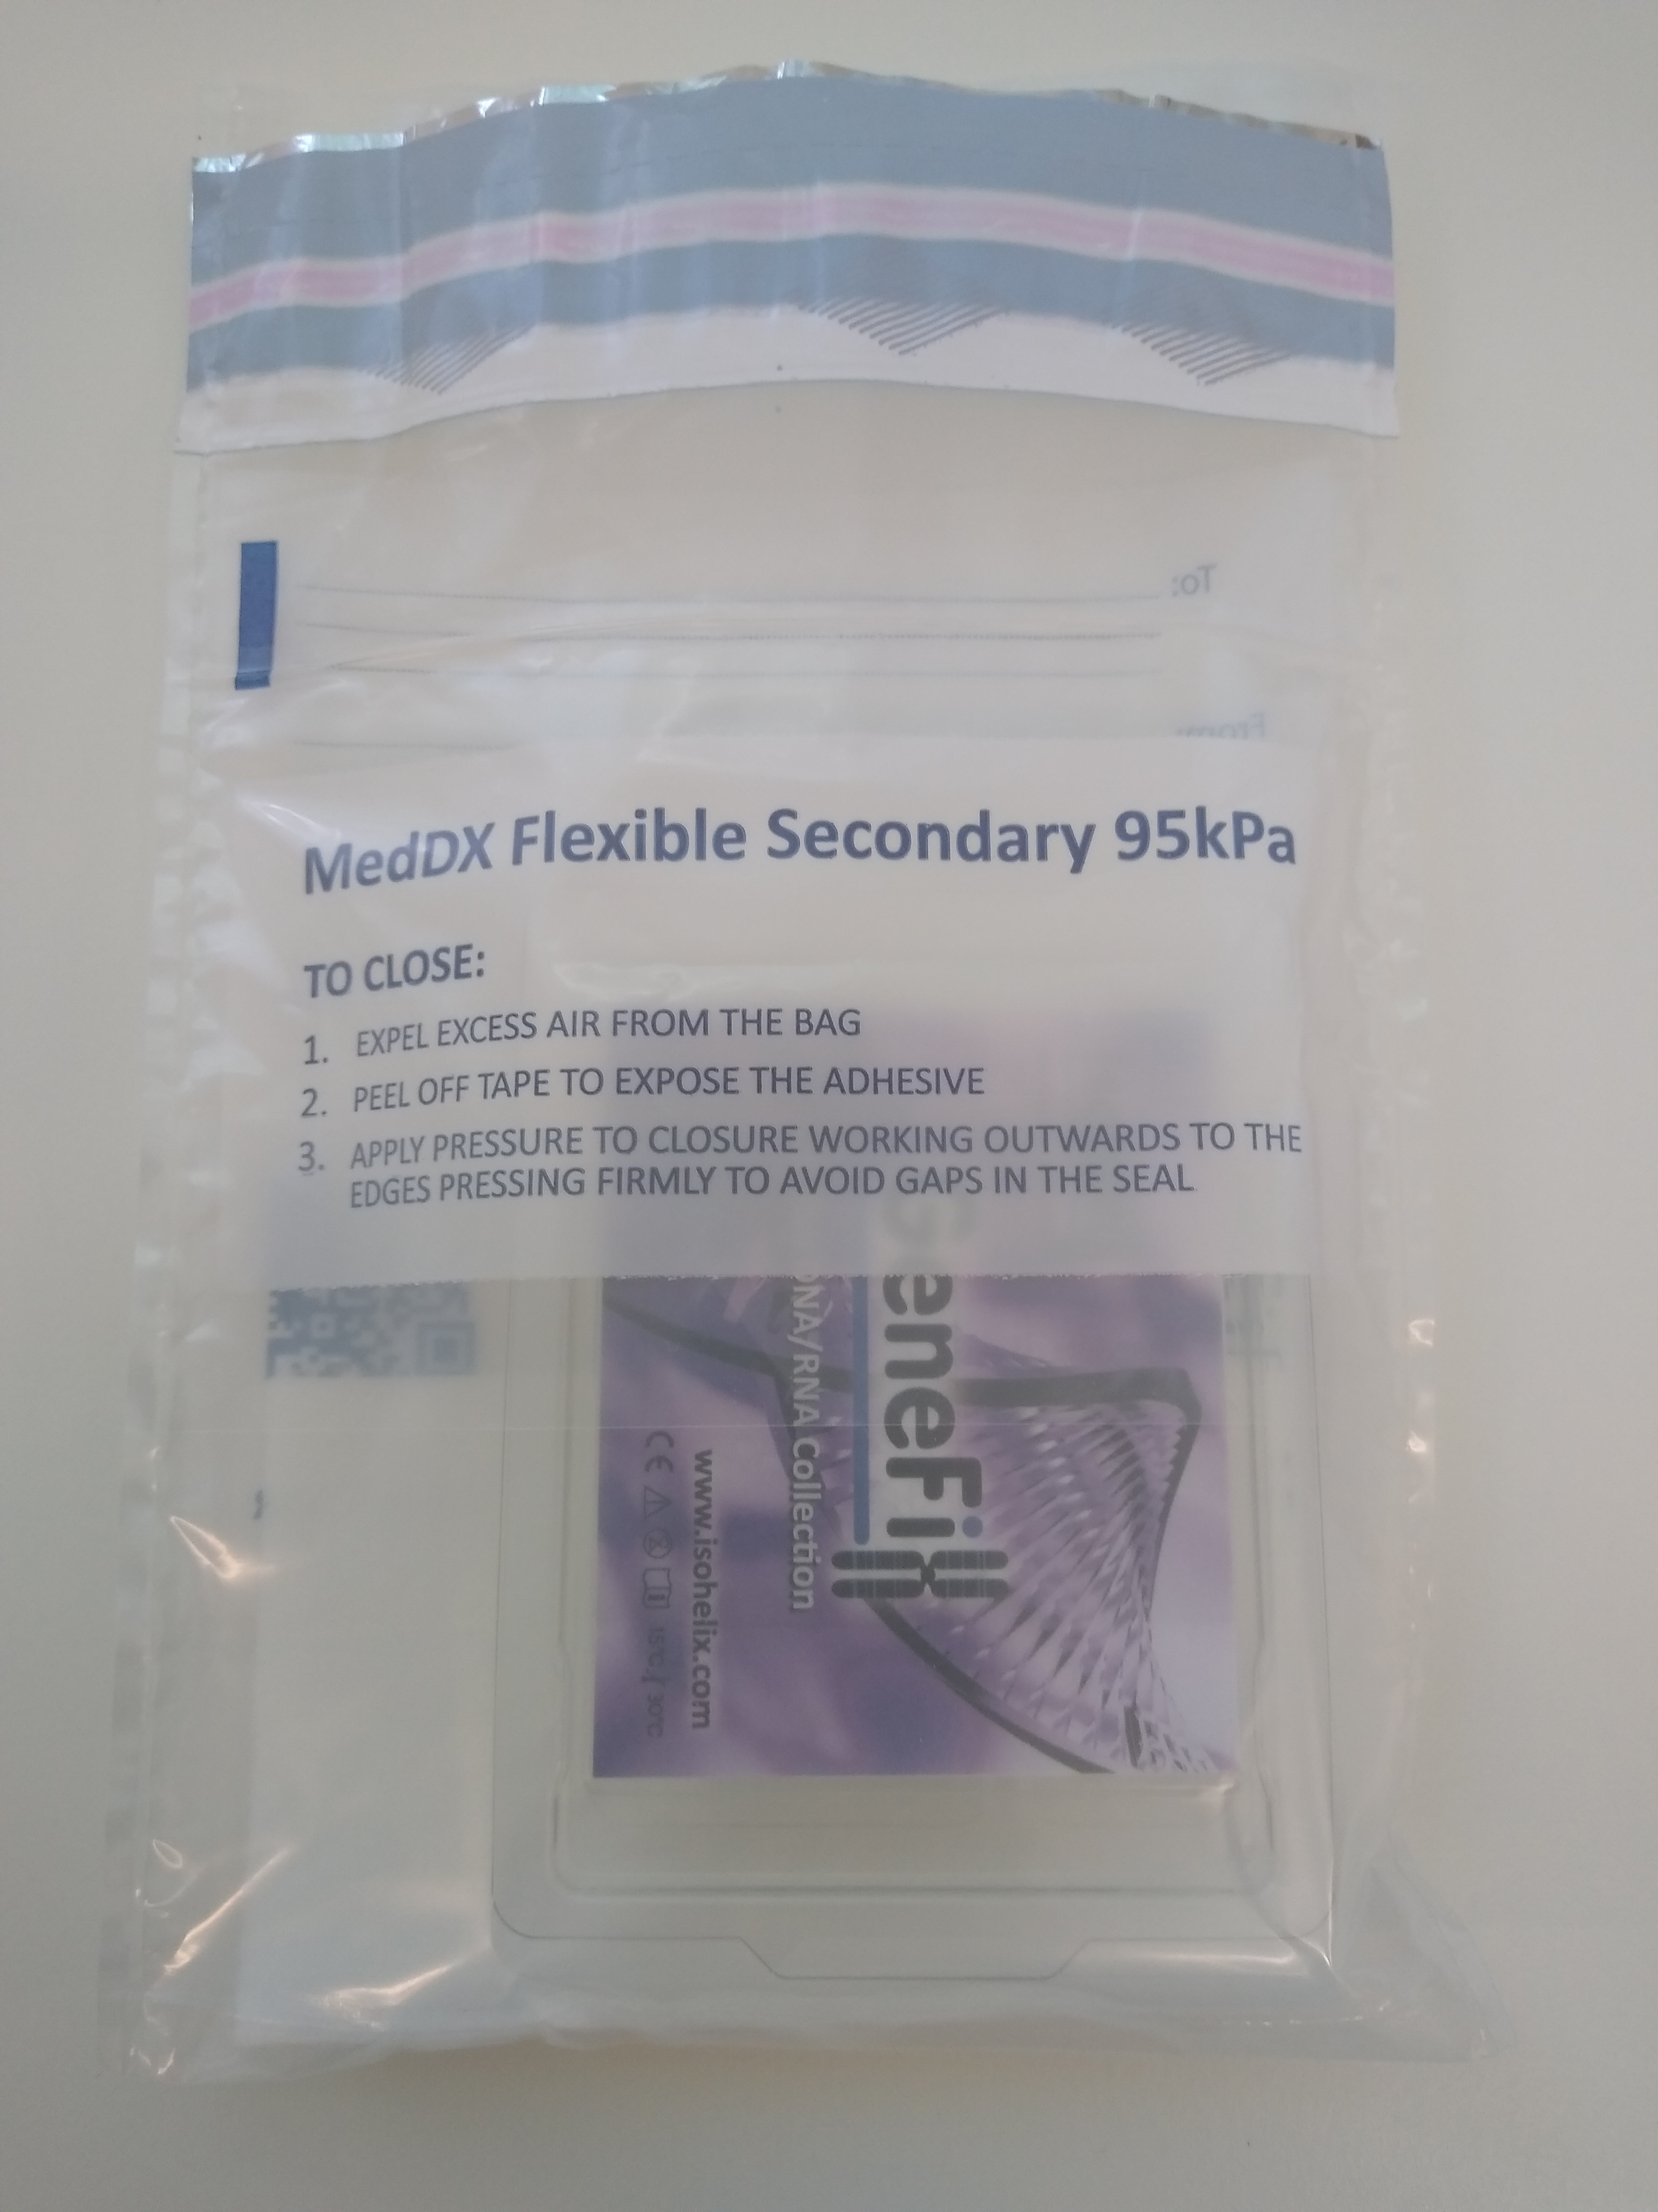
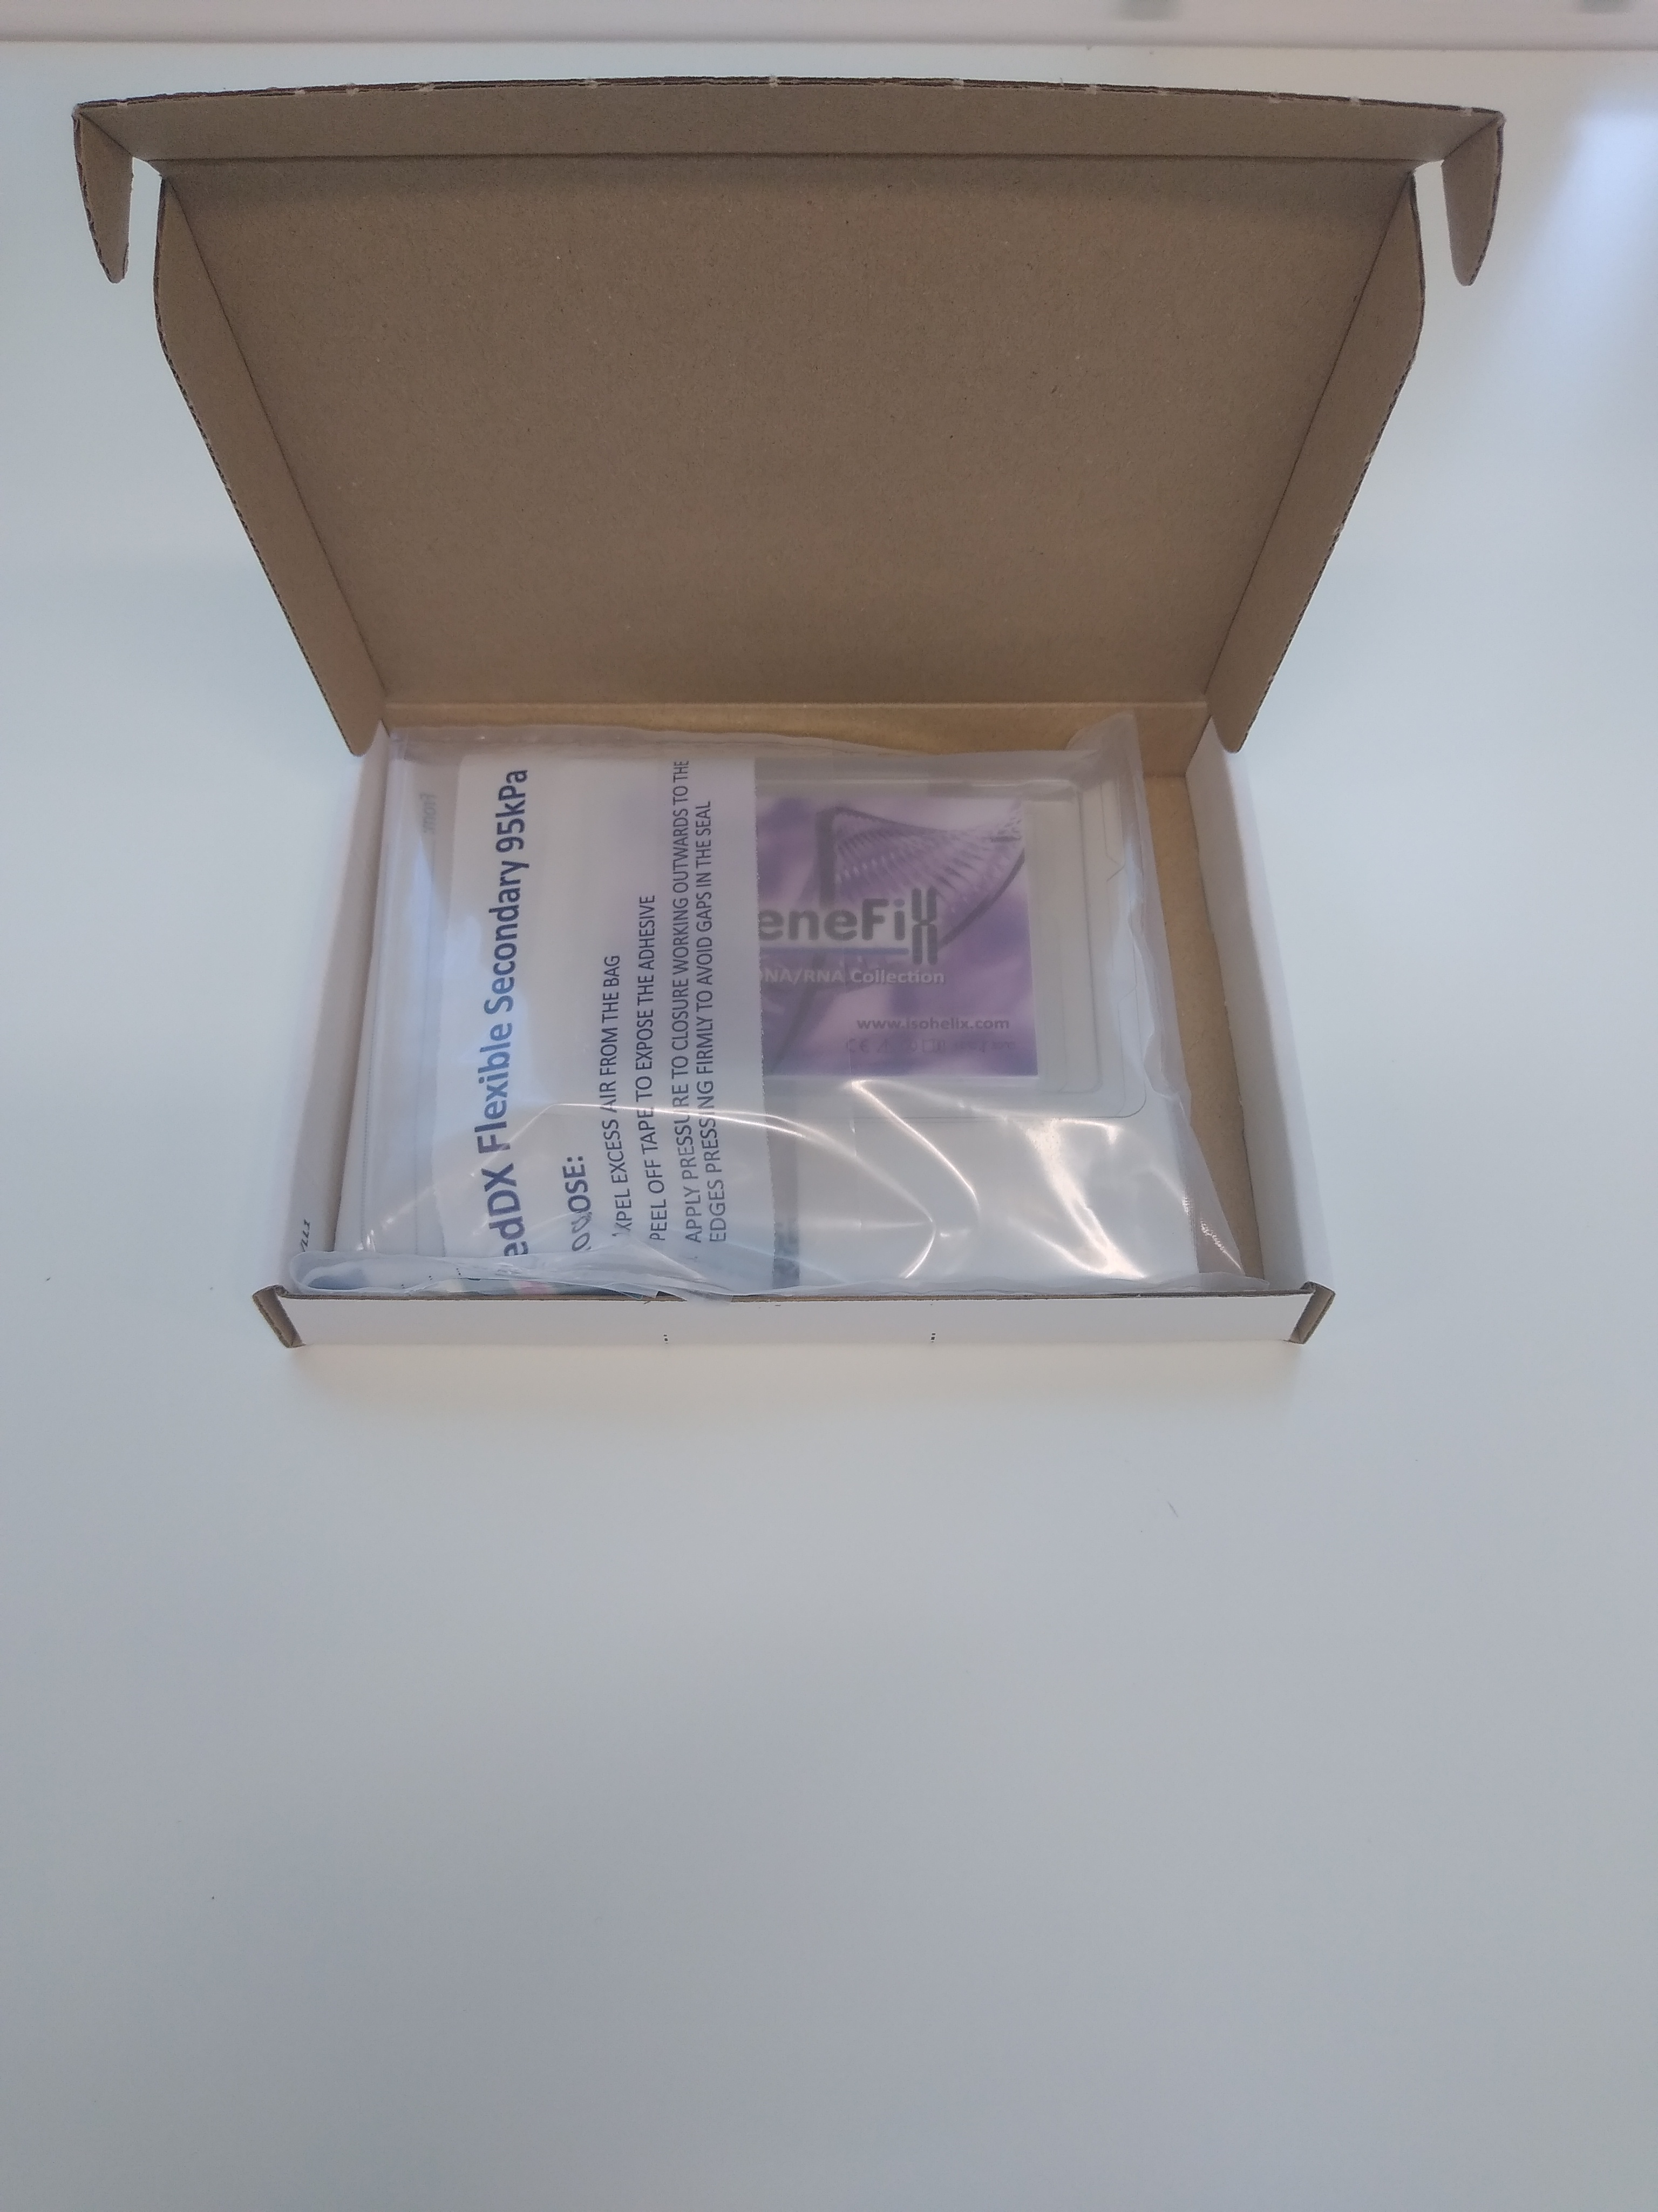

If you have any questions, please do not hesitate to contact me using the contact details below.

Kind regards,

XXX
Research Nurse
Hospital
Contact details of research nurse

